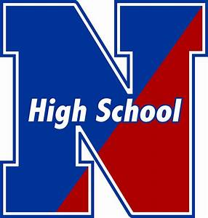NESHAMINY HIGH SCHOOL

ATHLETIC DEPARTMENT

Fall 2025 Athletic Registration Checklist

Please see below for the proper steps needed to participate in athletics for Neshaminy High School for the fall 2025 season.

□ **Sport Registration:**

* Complete the Google Doc
* [**https://docs.google.com/forms/d/e/1FAIpQLSd4TYGBknzy95pTnu-zjmc_wVZLEPF4EQ3aKn1brBc4OhI71g/viewform**](https://docs.google.com/forms/d/e/1FAIpQLSd4TYGBknzy95pTnu-zjmc_wVZLEPF4EQ3aKn1brBc4OhI71g/viewform)

□ **Physicals:**

* **Sections 1-6** of the PIAA Comprehensive Initial Pre-Participation Physical Examination form must be completed, signed by a doctor, and turned into the Athletic Trainer or Athletic Office prior to the following dates:
  + Football and Golf – **Monday July 28th**
* Physical **MUST** be dated on Section 6 after **May 1, 2025,** and **MUST** have a doctor’s signature.
* The whole packet must be turned into the athletic trainer or athletic office to be eligible to tryout on the first day of practice.
* <https://www.piaa.org/assets/web/documents/PIAA_CIPPE_FORMS_SECTION(S)_1_-_10(1).pdf>

□ **Concussion Education and Baseline Testing:**

* **Cheerleading, Field Hockey, Football, Soccer, and Volleyball athletes** must complete required Concussion Education and Baseline Testing.
* **NEW THIS YEAR!**
  + **Only 9th, 11th and transfer students need to complete the IMPACT baseline test.**
  + **ALL** athletes need to complete the education google doc component.
* Reach out to your coach for this information!